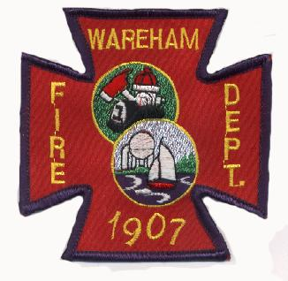 | WAREHAM FIRE DISTRICT BOARD OF ENGINEERS  Chief John G. Kelley  Asst. Chief Patrick M. Haskell  Acting Asst. Chief Christopher H. Smith  DATE OF MEETING: Monday, August 24, 2026  MEETING TIME: 10:00 a.m.  MEETING LOCATION: 273 Main Street, Wareham  POSTED: 8/19/26
AGENDA
- Call to Order
- Roll Call
- Approval of Minutes
- Correspondence
- Old Business
- New Business- Articles for upcoming Special District meeting
- Members Reports
- Announcements
- Adjournment

Patrick M. Haskell
Asst. Chief

